**Introduction to Dashboards**

**Building a Dashboard (Demonstration)**

**Statement:**

In this demo, we are building a dashboard using Global Superstore Dataset

**Solution:**

Forecast models capture the evolving trend or seasonality of given data and extrapolate them into future.

Forecast feature of Tableau desktop allows you to forecast quantitative time series data using exponential smoothing model. The exponential smoothing gives more weight to recent observations than older observations.

Let us get started with creating a rainfall forecast report:

**Step 1:**

* Click on the Sheet Tab and rename it as Running Total Profit by Segment
* Drag Segment field onto the Columns Shelf and apply a filter by selecting only Consumer
* Drag Profit field on to the Rows Shelf and apply quick table calculation of Running Total
* Drag Order Date field on to the Columns shelf and make it continuous measure
* Drag Category field on to the Colors Shelf
* Select Area chart option from the Marks Card

**Step 2:**

* Add another sheet and rename it as Profit by Sub-Category
* Drag Sub-Category field on to the Rows shelf and Profit field on to the Columns shelf
* Sort Sub-Category into descending order
* Drag Category field on to the Colors shelf

**Step 3:**

* Click the Dashboard Tab
* Drag Running Total Profit by Segment sheet on to the view pane
* Drag Profit by Sub-Category sheet on to the view pane
* Now, we can interact with the Dashboard using the Legends
* Select the Office Supplies option from the Category Legend, only Office Supplies part will be highlighted on the views

**Step 4:** Click the Filter icon on the Running Total Profit by Segment view

* Choose Filters 🡪 Category to filter the views on the Dashboard based on Category

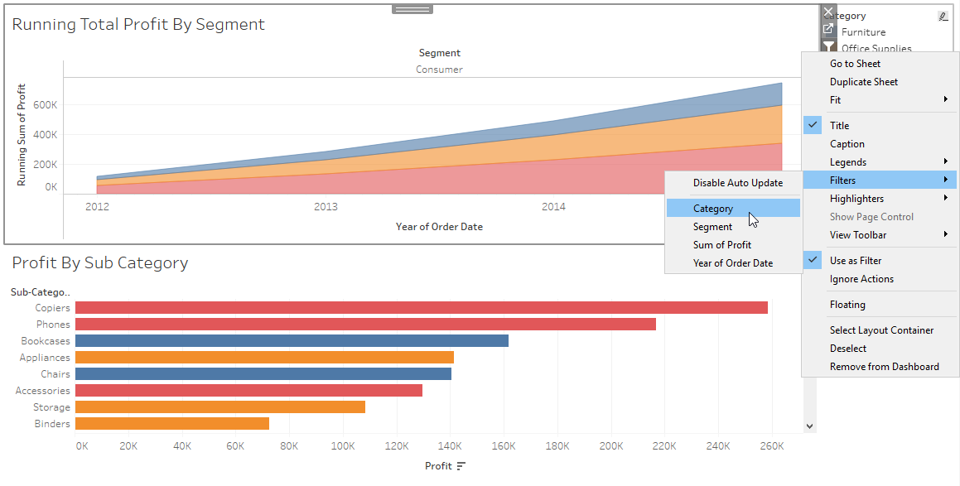

* Select any one amongst the Category filter, relevant information on the chosen category will be highlighted
* However, the filter is working only on the Running Total Profit by Segment view

* Click the drop down menu under Category legend and choose Apply to Worksheets 🡪 All Using This Data Source option in order to apply the interactive filter to all the views using this Data Source

